logo making it happen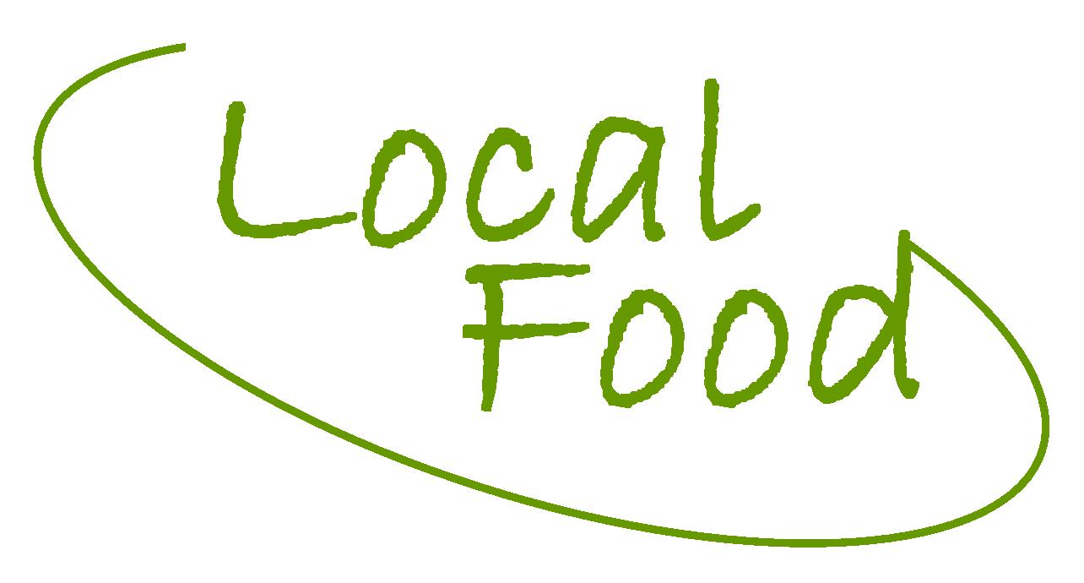

**Sustainable Food Economies**

**Tender Form - please complete the following:**

Contact Name:

Company:

Address:

Phone:

email:

Tendering for:

**Facilitation for Leicester pilot** ☐

**Facilitation for Dacorum pilot** ☐

**Facilitation for Staffordshire Moorlands Pilot** ☐

**Graphic design** ☐

**Website development** ☐

**Please explain briefly your understanding of the project requirements:**

**Please describe your proposed methodology and timetable illustrating your programme of work. This should include key tasks, deliverables and meetings with the f3 project team:**

**Please list key contact details of individual(s) we can contact with questions regarding your tender:**

**Please describe briefly the experience and track record of the named individual(s) who will be involved in the project:**

**Please provide some evidence of appropriate skills for the Project (see individual tender brief for details):**

**Please give a detailed breakdown of all costs, including travel expenses and VAT. Day rates should be included for named individuals:**

**Please give details of two referees to whom we can speak regarding work of a similar nature which you have supplied in last two years:**

**Please send your submission to:**

sfe@localfood.org.uk